How to remove a file

This is fun:

1. Delete the file “physically” from your PC (Mac sucks)
2. Open Bash: a $ git status will tell you a file has been removed, and appears in red. The red means the operation has been done physically but not virtually. So you have to do it virtually. This is how git will understand the operation and upload it to the web.

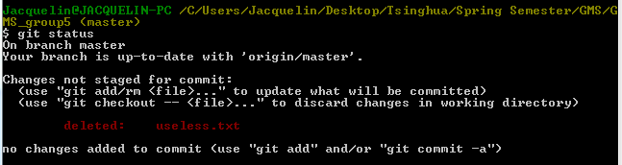

1. Okay. Now you deleted it on your pc, but have to make git understand that. For now, it is lost. So you will use the command “rm” (=remove):

$ git rm “name_of_the_file”

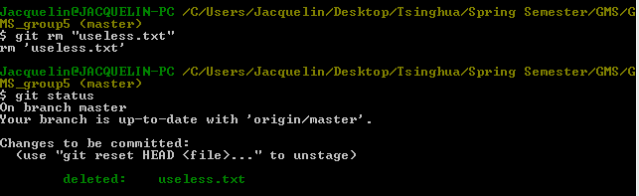

1. Pretty cool, the status now is shown in green, means git understood what you did. All you have to do now is to hold him by the hand to upload this operation:

$ git commit “deleting a file”

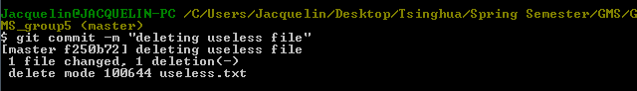

1. And push:

$ git push

